The Brussels Paper

A PlAn

# for

GlOBAl ECOnOMIC RECOVERY

John B Shing Li WU Rua De Pequim 174

Centro Comercial Kuong Fat 15E Macau

**Next**

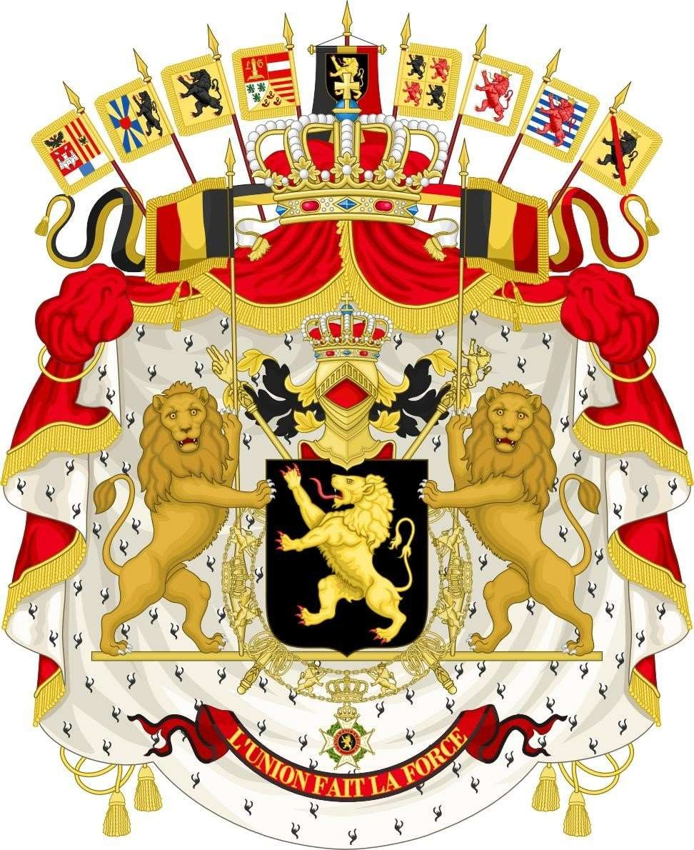

UNITED WE ARE A FORCE

**Next**

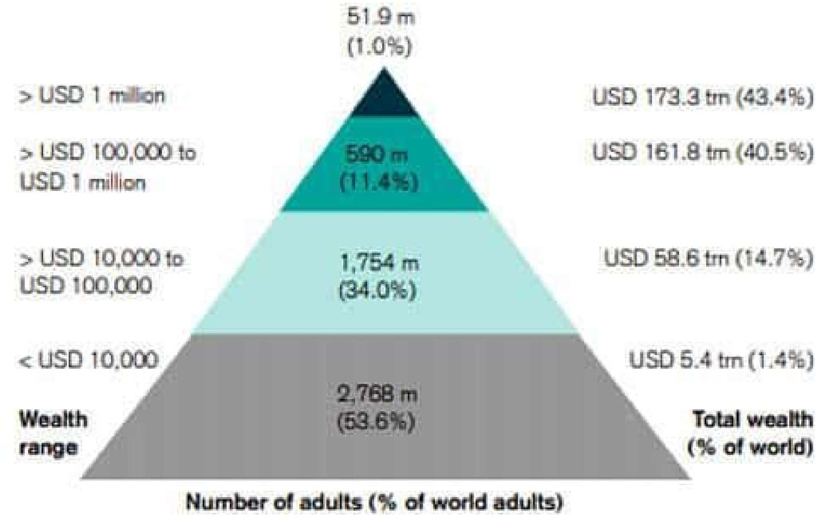

Pyramid Capitalism

45% of global wealth are in the hands of 1% humankind

The 1% club is destined to pass on their wealth to their next generation

The 45% Club's next generation awaits for A Circle Capitalism. This will not emerge without 100% participations

Cronies Capitalism The countries where politically connected businessmen are most likely to prosper

Capitalism Fabricated by our Heads without consulting Our Hearts Creates Economic Inequality.

Ultimately, millionaires and billionaires will pass on their wealth to their

next generation

**Recommended reading**

**Next**

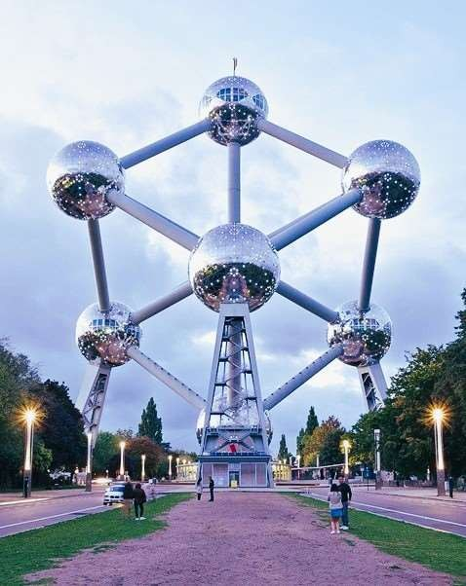

Circle Capitalism

**Next**

Requesting Your Participation

**Next**

**Brand ambassadors offer numerous advantages:**

* They give the brand a human touch.
* They strengthen the marketing and recruiting team.
* They are excellent helpers for the company's social presence.
* They are practical problem solvers.
* They can expand the market.
* They offer what customers are looking for: Honesty.

**Next**

Special thanks to:

* + Amy Hong

•

## Thank you for your contribution!